

## Department of Computer Science and Engineering (CSE)

Faculty of Science and Engineering

Semester: (Spring, Year:2021), B.Sc. in CSE (Day) PC

**Course Title: Structure Programming Lab Course Code: CSE-104 Section: B**

**Group Name: S-500**

**Lab Project Name**: **Cyber Cafe Management and Security System**

## Student Details

|  |  |  |
| --- | --- | --- |
|  | Name | ID |
| **1.** | **Samia Nowshin Oishi** | **211902009** |
| **2.** | **Md. Jahid Hasan** | **211902027** |
| **3.** | **Md. Mehedi Hasan** | **211902028** |

**Submission Date : 14 September, 2021**

**Course Teacher’s Name : Farhana Akter Sunny**

**[For Teachers use only: Don’t Write Anything inside this box]**

### **Lab Project Status**

**Marks: ………………………………….. Signature: ……………………………………………**

**Comments: …………………………… Date: ………………………………………………….**

**Contents:**

**Chapter 1 Introduction Page**

1.1 Introduction ------------------------------------------------------------ 3

1.2 Statement of the Problem ------------------------------------------ 3

1.3 Scope of the Work ---------------------------------------------------- 3

1.4 Design Goals ----------------------------------------------------------- 4

1.5 Outline ------------------------------------------------------------------ 4

**Chapter 2 Design Methods and Procedures**

2.1 Introduction ---------------------------------------------------------- 5

2.2 Section ----------------------------------------------------------------- 5

2.3 Section ----------------------------------------------------------------- 6

2.4 Summary -------------------------------------------------------------- 6

**Chapter 3 Performance Evaluation**

3.1 Introduction ---------------------------------------------------------- 7

3.2 Simulation Environment/Simulation Procedure ------------ 7

3.3 Basic Data ----------------------------------------------------------- 10

3.4 Results and Discussions ------------------------------------------ 10

3.5 Summary ------------------------------------------------------------- 10

**Chapter 4 Conclusion**

4.1 Introduction ---------------------------------------------------------- 11

4.2 Discussion/Concluding Remarks -------------------------------- 11

4.3 Practical Implications ---------------------------------------------- 11

4.4 Scope of Future Work --------------------------------------------- 11

**References** ----------------------------------------------------------------------- 12

# Chapter 1 INTRODUCTION

**1.1 Introduction.**

A cyber cafe Management System is a real-time way to manage the client machines via monitoring and locking to process including the ability to control and charge for printing fully. A Cyber-cafe is a type of business where computers are provided to access the internet, play games, chat with a friend, or do another computer-related task. In most cases, access to the computer and internet is charged based on time. A cyber-café is also known as an internet cafe.

# 1.2 Statement of the Problem.

The purpose of our project is to learn how to manage a cyber-café properly, such as providing high-quality security, keeping customer information secure, etc. The main object of the cyber-café management system is to manage the details of ID proof, Customer Account, Customer Account List, search available computer, Edit Account, Delete Account, Charge of Computer user.

# 1.3 Scope of the Work.

The current system is an application program that provides a better way to management of Cyber-cafes. Users those who have an account with the system are entertained. Creation of account is however very easy. The new system provides the following features

* Eliminate the limitations of existing system
* Efficient storing of user details
* Allocation of available cabins
* Automate billing process by calculating time and amount
* To prevent cyber-crime through cyber-cafe
* The system can provide the daily report including customer details, login, amount, cabin and the total collection of a day

# 1.4 Design Goals.

The main objective of the Cyber-cafe management system is to manage the details of

ID Proof, Charges, Customers, Usage. It contains all the information about

Computers, Usage, ID Proof. The project is built at the administrative, and thus, only the administrator is guaranteed the access. The project aims to create an application program to reduce the manual work for managing the Charges, Computers, Customers. It tracks all the details about the Customers, Downloads, Usage, and matches more.

# 1.5 Outline.

In this System, it is very easy to add, read and delete contacts. The whole project is designed in ‘C’ language, and different variables, functions, and strings have been used to develop this project. We have also used Binary File Operation to keep all contacts saved.

# Chapter 2

The Design Methods and Procedures

**2.1 Introduction.**

This project study is focused on the design and development of a security software package for S-500. This research work came into existence a time when the internet café business is becoming very popular and vast. The principal objective of this project is to stop or deny access to an unauthorized user and also to ensure proper accountability of cash received by the ticket issuers. Therefore, the design and development of this internet security software package for S-500 is worthwhile.

# 2.2 Section.

Cyber-Cafe S-500

Admin Login

Check for the

username and

password

If Invalid

Main Menu

If Valid

Add Account list

View Account

Search Computer

Edit Account

Delete Account

Help

Exit

Return Admin Login

**Figure 2.2: Cyber-Cafe S-500**

# 2.3 Section.

Here we can see on figure 2.2 the sections of our system. Here, when the admin starts the system, the system will ask him for ID proof. It will then match the data in the system. If not, the admin must take it again. If found, it will take you to the main menu. From here you can access add account, view account, search computer, edit account, delete account, help, Exit sections. If we select Exit, the system will take us back to the admin Login page.

And again, we have to access the system with the complete ID Proof.

# 2.4 Summary.

Even though this is written last, it’s placed first to introduce your business plan. It should be a quick read and spark interest to hear more and should be brief and kept to one page. Overview of the main points from each section of your plan, highlighting key strategic points:

mission & vision- what your business is doing for customers now and in the long run products/services- brief description keys to success- what sets you apart from your competition location & target market- overview and why you’ll succeed here owner and management team- who and why they’re the right team for your business specific & measurable objectives- growth highlights, financial forecasts, etc.

financial overview- start-up costs, expenses, revenue, profit, and source of funds any other significant key points.

# Chapter 3 Performance Evaluation

# 3.1 Introduction

In this section, we will simulate our code here and show some of the functions of our project.

# 3.2 Simulation Environment/Simulation Procedure

Main: Here Administrator can log in.

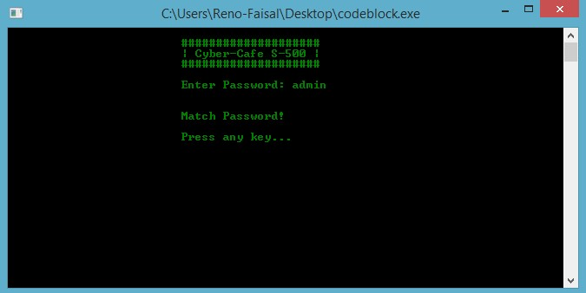

Log in: Here if Administrator enter wrong password…

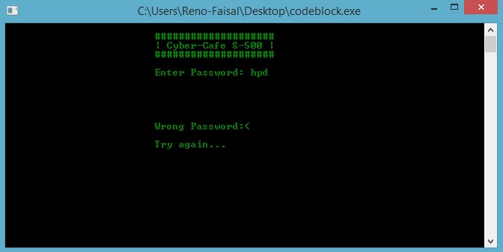

Main Menu: Here Administrator can go to any option for their particular work.

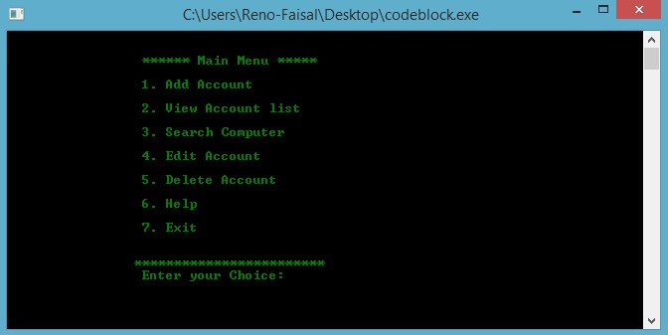

#### Add Account: Here Administrator can Add Account

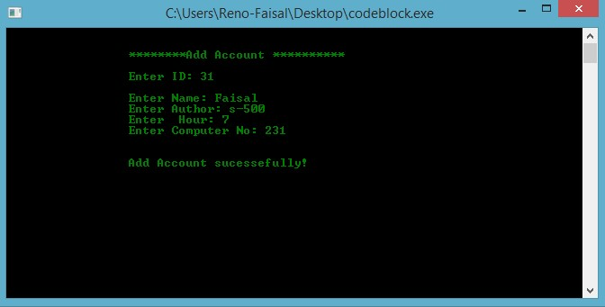

#### When ID is already having, then…

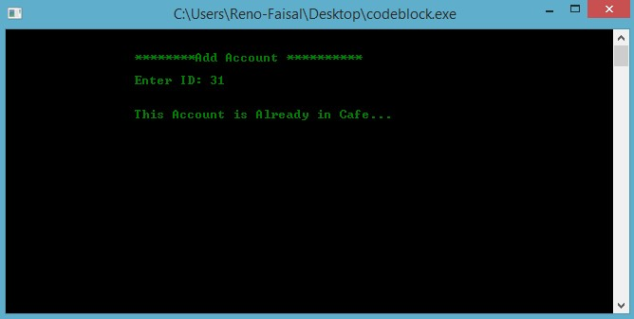

View Account List: Here Administrator can view entered Account

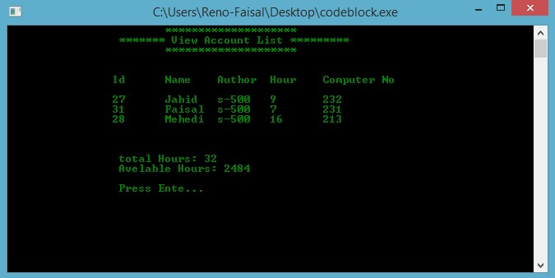

#### Search Computer: Here Administrator can Search Computer…

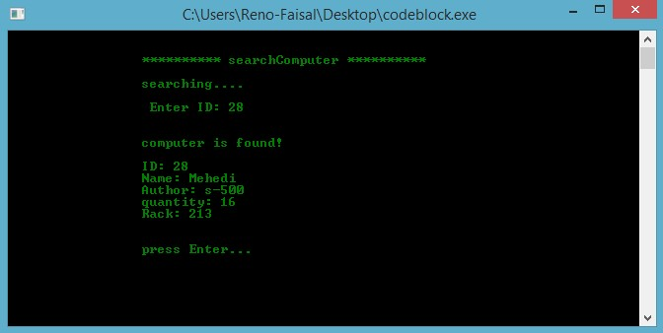

Continue…

# 3.3 Basic Data

* C – Basic Datatypes.
* C – Variable Types.
* C – Operator Types.
* C – Input and Output.
* C – using Functions.

#### 3.4 Results

Our project was working properly, though there were some bugs. But we achieved our goal.

# 3.5 Summary

This project is focused on the design and development of a security software package for S-500.

This research work came into at a time when the Cyber-café business is becoming very popular. The principal objective of this project is to stop or deny access to an unauthorized user. Therefore, the design and development of this internet security software package for S-500 are worthwhile.

# Chapter 4 Conclusion 4.1 Introduction

In this chapter we are going to discuss the project outcome.

### 4.2 Discussion

Great skills have been achieved during the development of this project, time management is one of them, research in various areas of c programming and at the end of the day it can be said that the task has been a great success incorporated with challenges. These experiences will be used forever.

# 4.3 Practical Implications

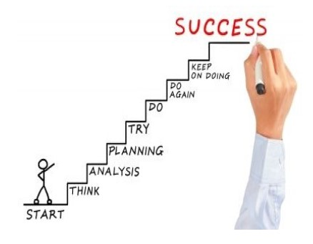

Figure 4.3: Success phase

# 4.4 Scope of Future Work

The system is made for keeping information about all computers of a Cyber-cafe. Updating and retrieving in a fast and accurate way. It will help people to save contacts and they can access their data when it is necessary. In the future, we can update it and use it on android devices. We also can edit the code to take other information as well. We also can edit the code and make it library management or an office management system.

# References:

1. <https://stackoverflow.com/questions/13566082/how-to-check-if-a-file-has-content-or-not-using-c>
2. <https://c-for-dummies.com/blog/?p=69>
3. <https://www.tutorialspoint.com/c_standard_library/stdlib_h.htm>
4. <https://beginnersbook.com/2014/01/c-strings-string-functions/>
5. <https://www.geeksforgeeks.org/use-fflushstdin-c/>